* Mr. Bhuvnesh Bhardwaj filed a patent on “Apparatus and method for cleaning inner surface of hollow object” (file no. 4307/DEL/2015).
* Ankit Bhardwaj (VII sem) successfully completed 45 days summer internship from Sultan Qaboos University, Oman from 19 June to 07 Aug. 2015.
* 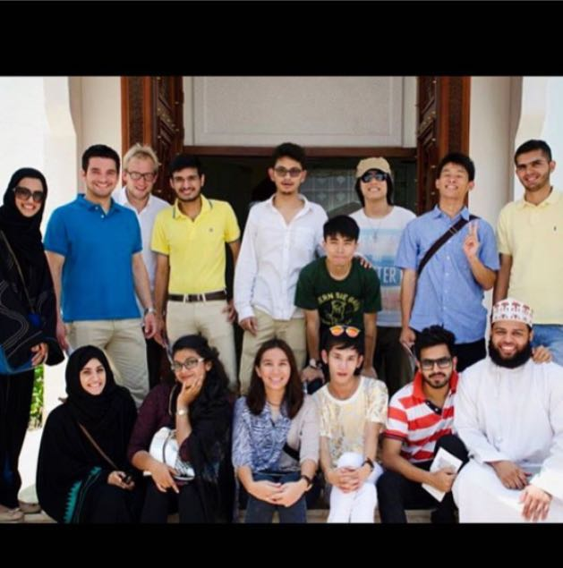

A Team of five students from department participated in Virtual BAJA, SAE India 2015 at Chitkara University, Patiala on 11 July 2015

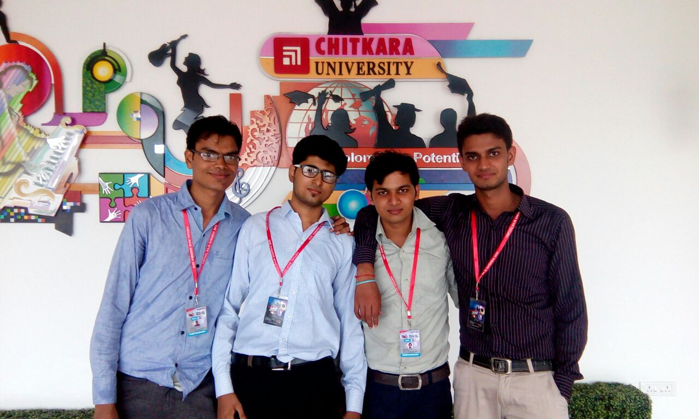

* Sumit Gupta & Sunil Gupta (VII sem) successfully completed the Code vita contest conducted by TCS during 7-8 August 2015.
* Amit Modi(V sem) submitted a project in E-summit’15 at IIT Kanpur on 30 August 2015.
* Shubham Agarwal, Rohit Mehta and Ishan Swami(V sem) delivered a presentation at Institution of Engineers, Jaipur titled “Engineering Challenges for Knowledge Era” on 13 Sep.2015
* 94 Students from our department participated in SAE-North India student convention at SKIT, Jaipur on 10 Oct.2015.
* A team of five students participated in RC car competition at College of Engineering, Pune during 10-11 Oct.2015
* A team of 10 students participated in the final round of SAE-Effiyan competition at LPU, Jalandhar during 15-17 Oct.2015 and stood at 17th place among 111 teams registered from across the country.
* 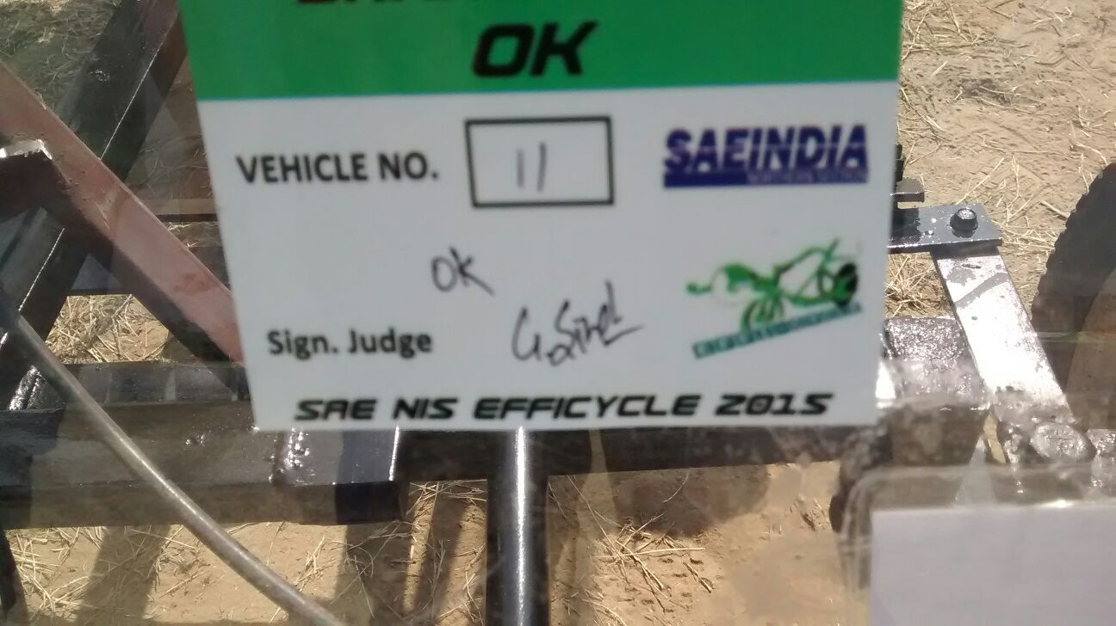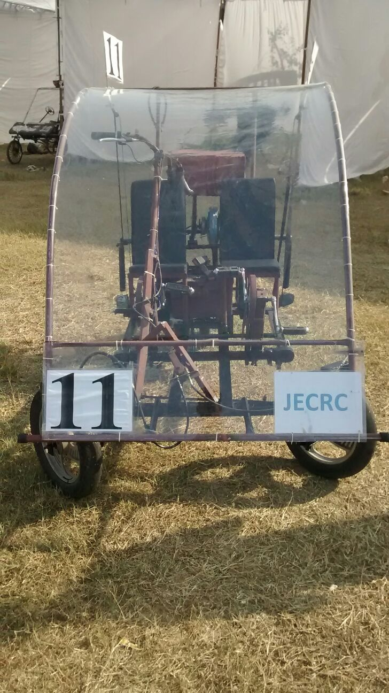
* 48 students(III sem.) undergone short term practical training from companies/institute like:

1. Renault
2. Nissan
3. CIPET
4. Hyundai and

Rajasthan Machinery Mart

* Two students of V Sem. were selected in JECRC cricket team for a tournament held at IIT- Jodhpur on 29th Nov. 2015, where our team finishes at third place.
* Two students of III Sem. won the R P Varshney Quiz competition at Indian Institute of Metal, New Delhi Chapter.
* 5 Teams consisting of 2 members each, participated in Auto Quotient session- 7 at Arya college Kukas, Jaipur on 4th Dec 2015.
* 42 students of III sem. along with two faculty members went for an Industrial Visit to HMT, Ajmer on 17/12/2015.

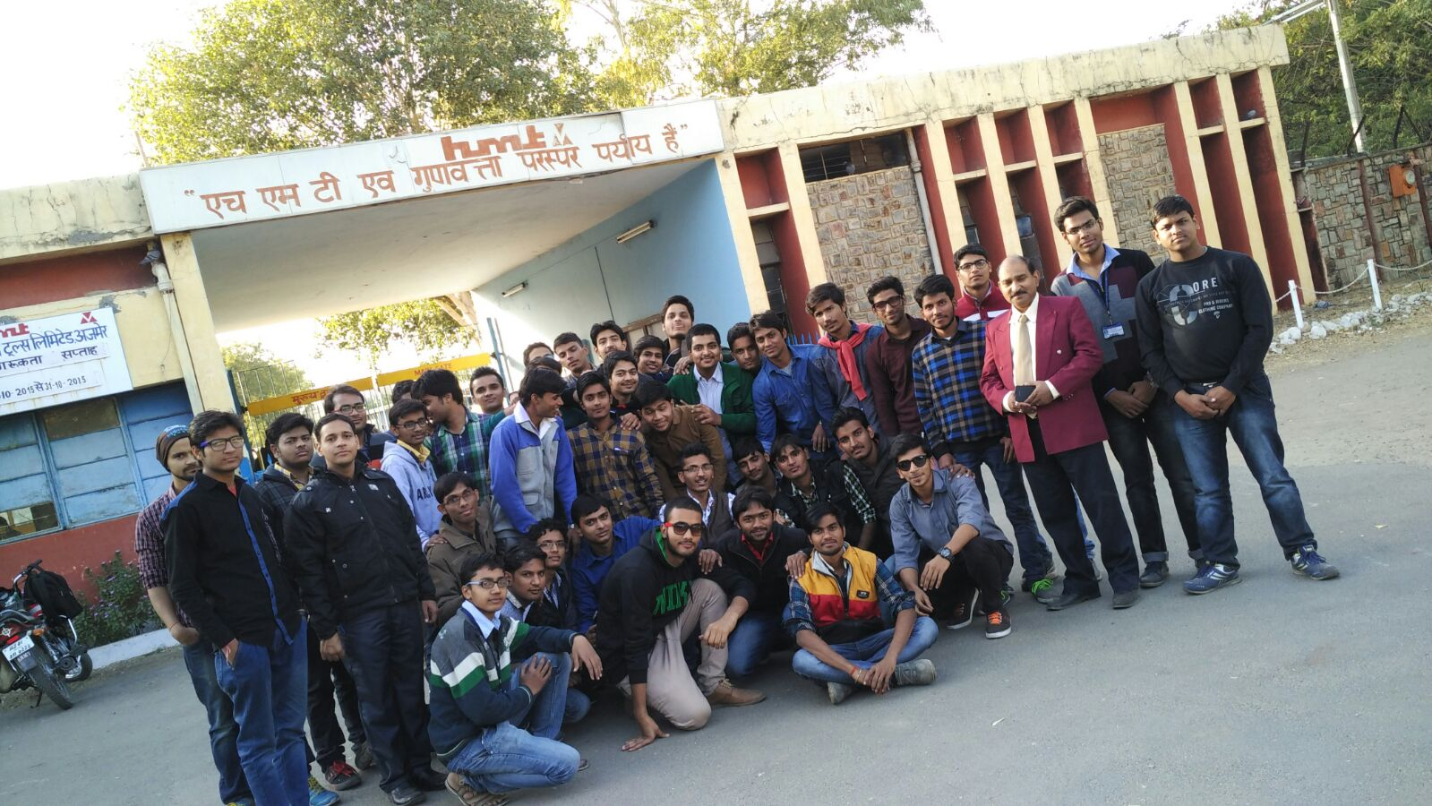

* 15 days Work shop on ATV design and development from 08Feb-22Feb 2016 conducted by Elite Techno Group(From the Team of Formula Racing Marshal)at JECRC campus.

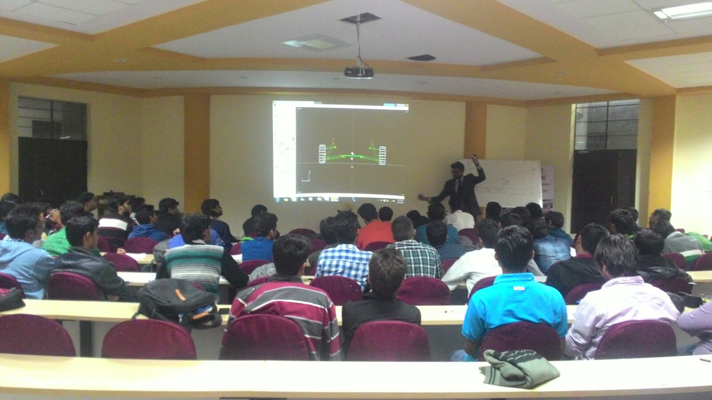

* 5 students of 3rd yr attended three day workshop at IIT Bombay during Aerowink- (Tech fest) from 26-28 Dec.,2015.
* 10 students of 2nd year attended Two days Workshop on Automobile Mechanics & IC Engine at IIT Delhi (Tryst-2016) during 28-29 Feb,2016
* 30 students participated in First National level Mechanical Olympiad,NLMO-2016 on 27 Feb,2016 at JNIT, Jaipur.
* Shahjade Alam of 2nd year ME participated in Debate competition on 27 Feb,2016 at JNIT,Jaipur ,and won First Prize. He also participated in Business Plan Competition and won 2nd Prize.
* A team of 5 students participated in RC car event at IIT, BHU on 03 March,2016.
* Aman Gupta of 3rd year ME won the first prize in Robo War competition at Gyan Vihar University during 24th-27th Feb,2016.
* He also won the first prize in RoboWar competition at JECRC University in Rhythm- 2016.
* Shubham Gupta of 3rd year ME won the first prize in Quiz competition organised on National Scince Day-2016 at S S Jain Subodh PG college,Jaipur.
* He also won the first prize in Debate competition in the same event.
* He also won the second prize in Essay competition on “Ease of doing business for higher productivity and sustainable growth” organised by Rajasthan State Productivity Council on 15 Feb-2016
* Sachin S Katiyar of 3rd year ME was the team member of JECRC who won the first prize in Gali Football at KITE,Jaipur.
* Santosh Rawat of 3rd year ME successfully completed certification course of NCC during 08 Jan-19 Jan 2016
* Gyan Prakash & Aviral Jakhar of 4th year ME presented research paper on “Ergonomic Chair” at Vivekananda Global University (ICRTMME-2016) on 8th-9th April,2016.
* Dharmesh Sharma & Gaurav Gadodiya of 3rd year ME presented research paper on “Study of effect of EDM parameter on surface roughness, toolwear & M.R.R” on Feb 26-27th ,2016 at Rajhdhani Institute of Technology & Management (AMITME-2016),Jaipur
* Sachin S Katiyar of 3rd year ME was the team member of JECRC who won the first prize in Gali Football at KITE,Jaipur.
* Santosh Rawat of 3rd year ME successfully completed certification course of NCC during 08 Jan-19 Jan 2016.
* Two teams of 2nd year ME participated in RC car competition at IIT, Jodhpur during 25-28 Feb,2016 and won First and Third prize respectively.
* Kushagra Choubisa of 3rd year ME develop a Android App for Renaissance-16 under Centre for Apps & Ideas.
* Shubham Saxena of 3rd year ME develop a Website “vidcampus.com”, provides technical material i.e. Lecture notes, RTU papers, Technical videos etc. for UG students.
* Yash Sharma and Vijay Sharma of 3rd year ME participated and qualified for the final round in RC car competition(TECHKRITI-16) at IIT,Kanpur during 3-6 March-16
* A team of 30 students of ME department participated in Mega ATV Championship.This competition was organized in the city of temples Bhubaneshwar by the AutoSports India, BAJA Tutor in association with Kalinga Motors Sports Club, Supported by Ministry of Sports Government of Odisha, FIA (Fédération Internationale de l'Automobile) and FMSCI (Federation of Motor Sports Clubs of India) during 4-7 March 2016.

This championship is an All Terrain Vehicle (ATV)/ Dune buggy/ Mini BAJA racing competition based on real life challenges and disaster management situations using ATV’s. It is an engineering design, manufacturing, racing and utility based competition in which teams from across the country have to design and fabricate their ATV to serve the mankind

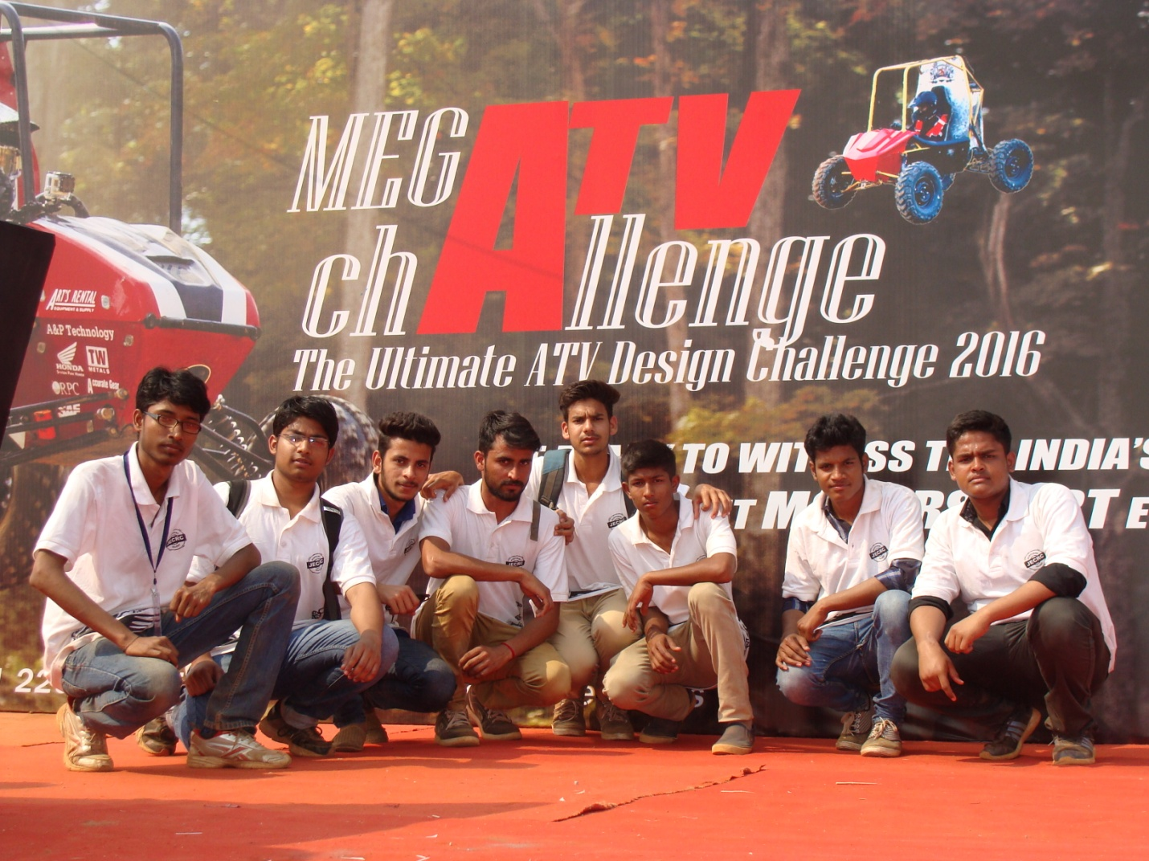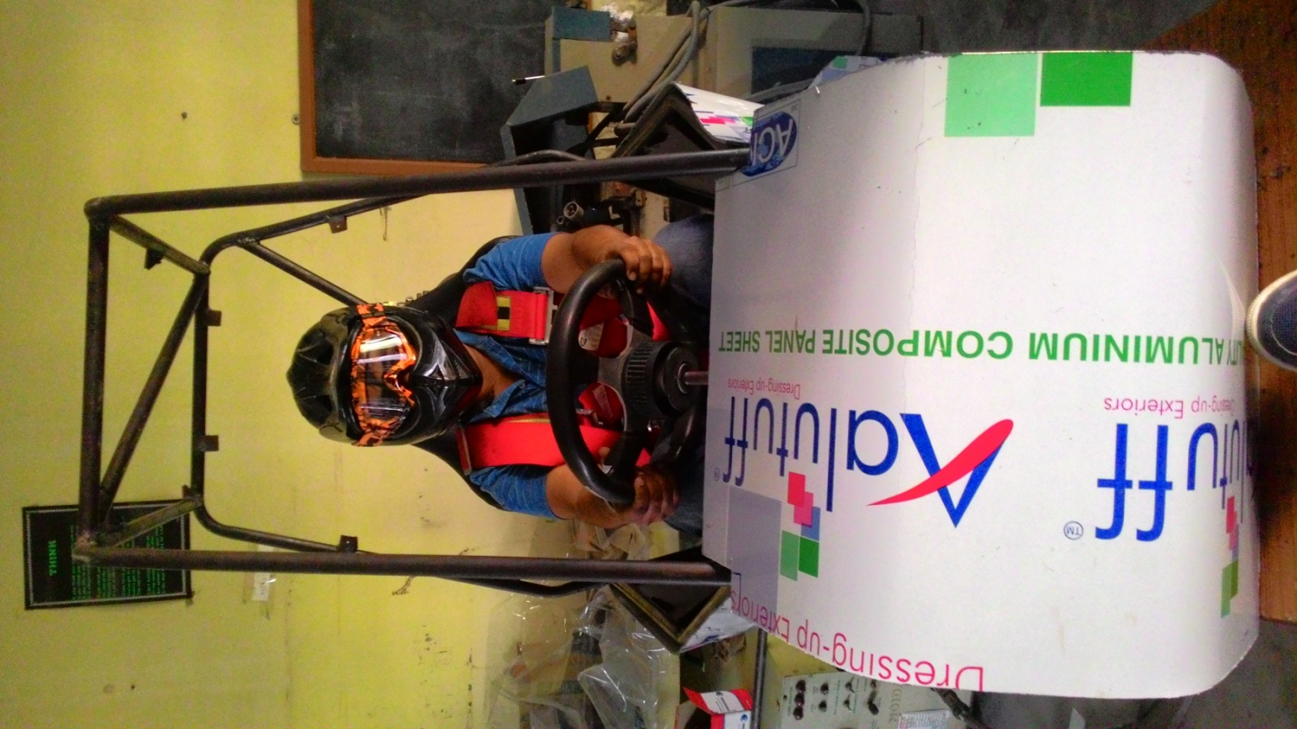

* A team of 10 students of ME participated in “Off Road Battle-2016”. This is an Engineering Design competition organized by the SAE Collegiate Club of Gautam Buddha University(GBU), Noida in association with Polaris India Pvt Ltd during 28-30 March,2016. The Event was organized for the first time by the University followed by National Level Hybrid Tricycle.

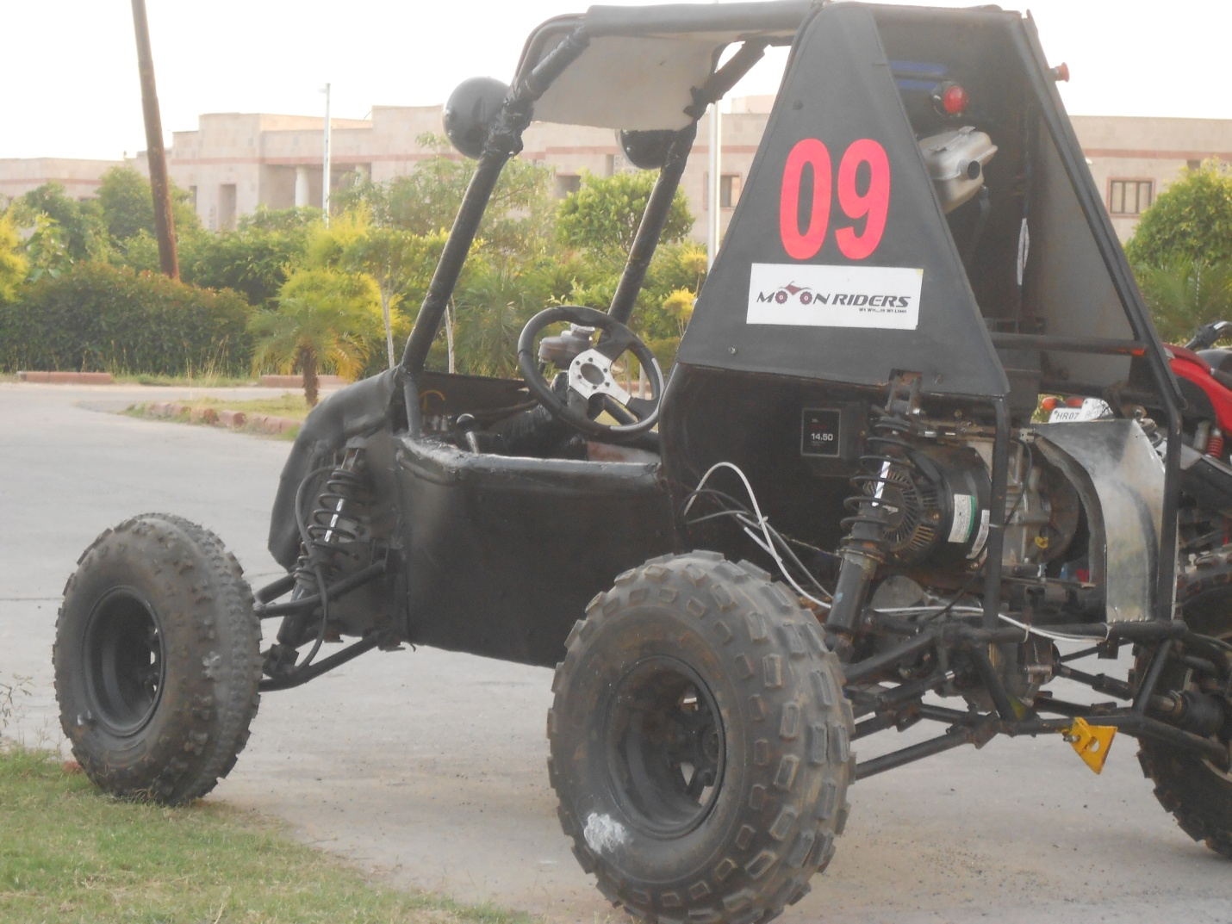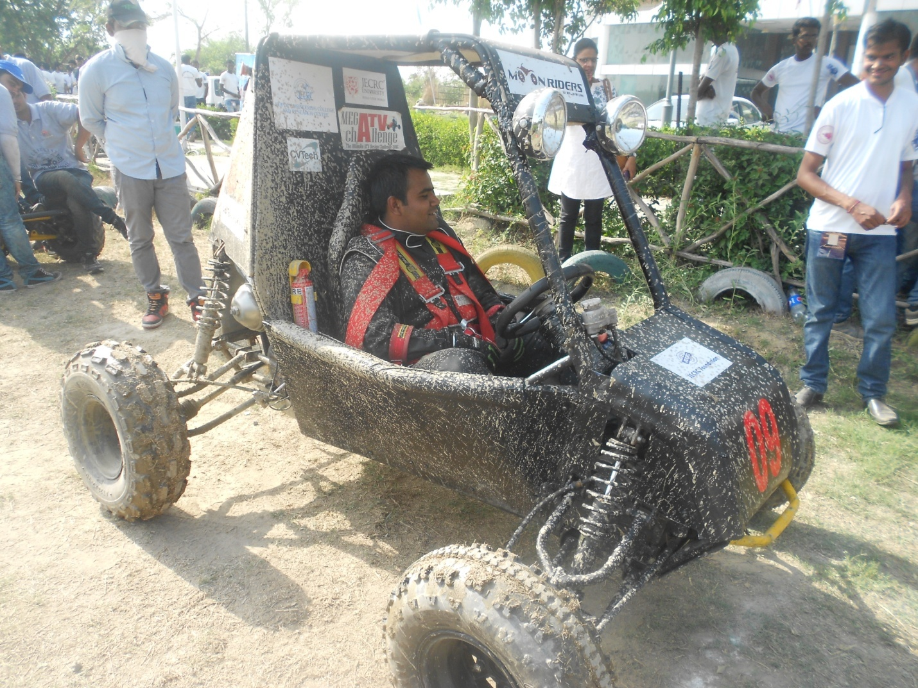

* ICT based short term training course was organized by department in association with NITTTR, Chandigarh on “Sustainability Development: Challenges & Opportunities” during 12-16 Oct. 2015.

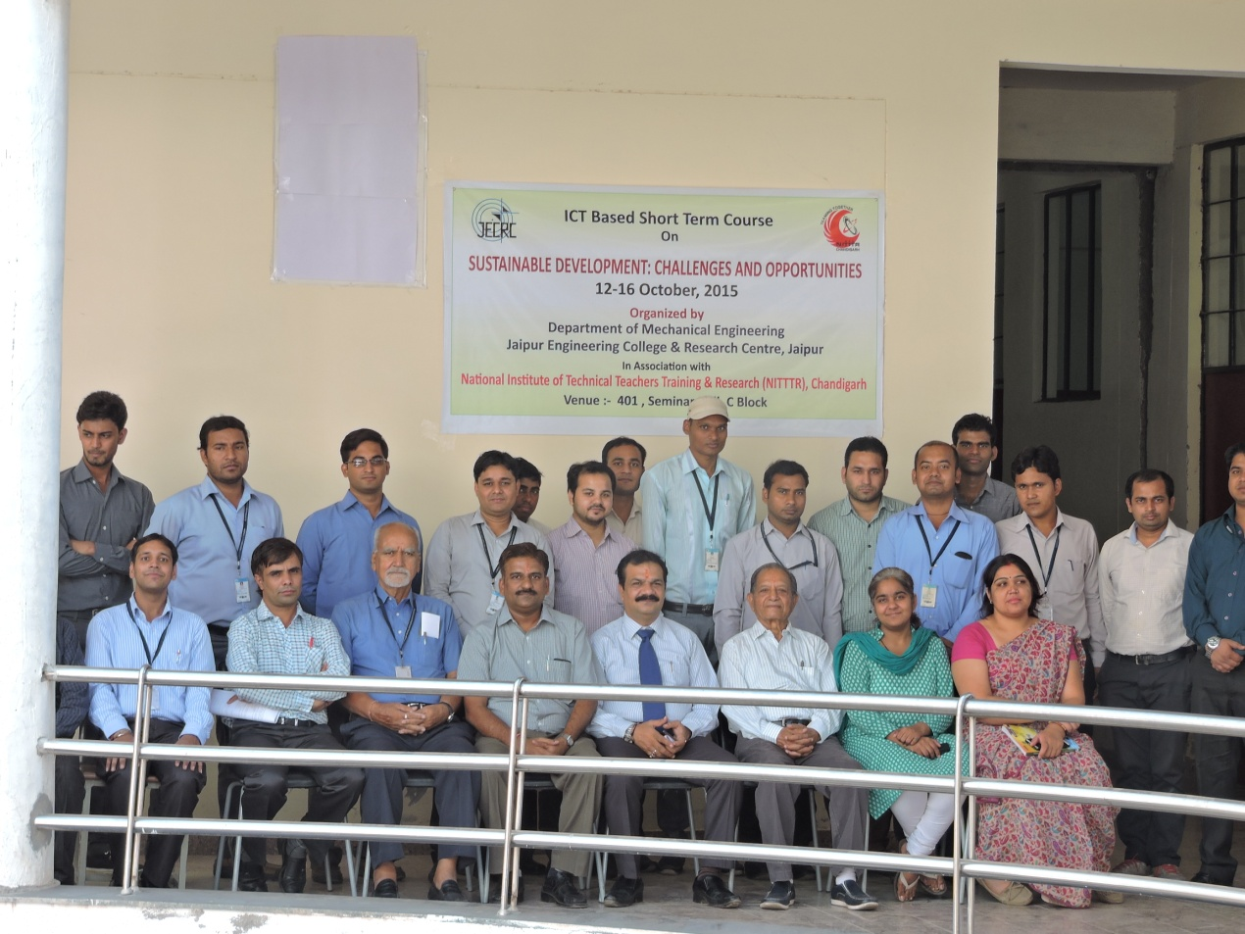

Mr. Siddharth Singh, Business Head-TechieNest delivered a talk on “Automatic Teller Medicine Machine” for III Sem. and V sem students on 29th Oct,2015

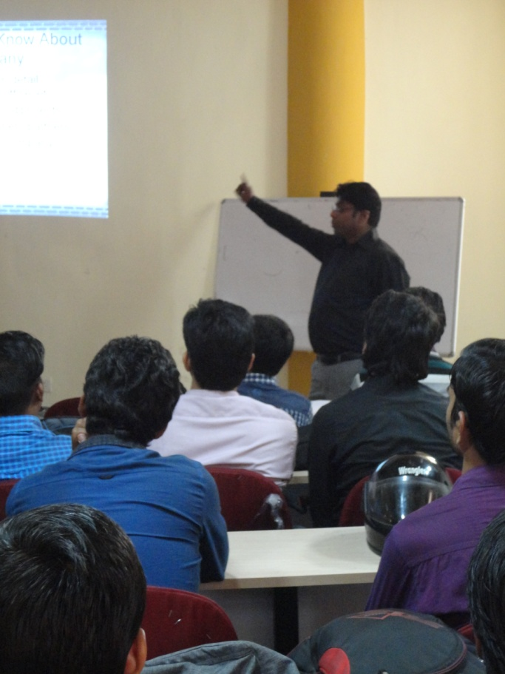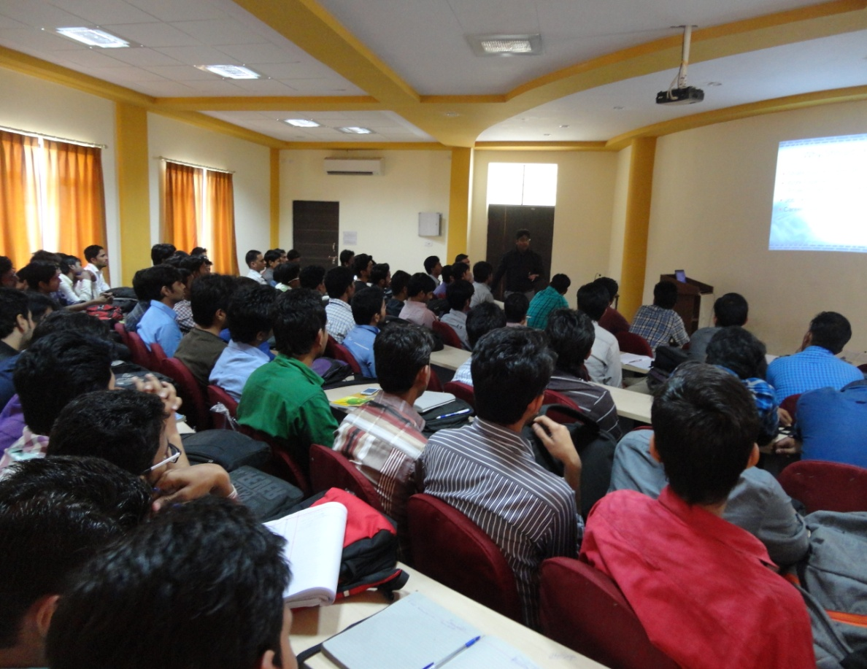

* Mr. Nimesh Baba of Baba Automobile Training Centre delivered a lecture on “Practical Aspect of Automobile Engineering” on 09 March 2016.

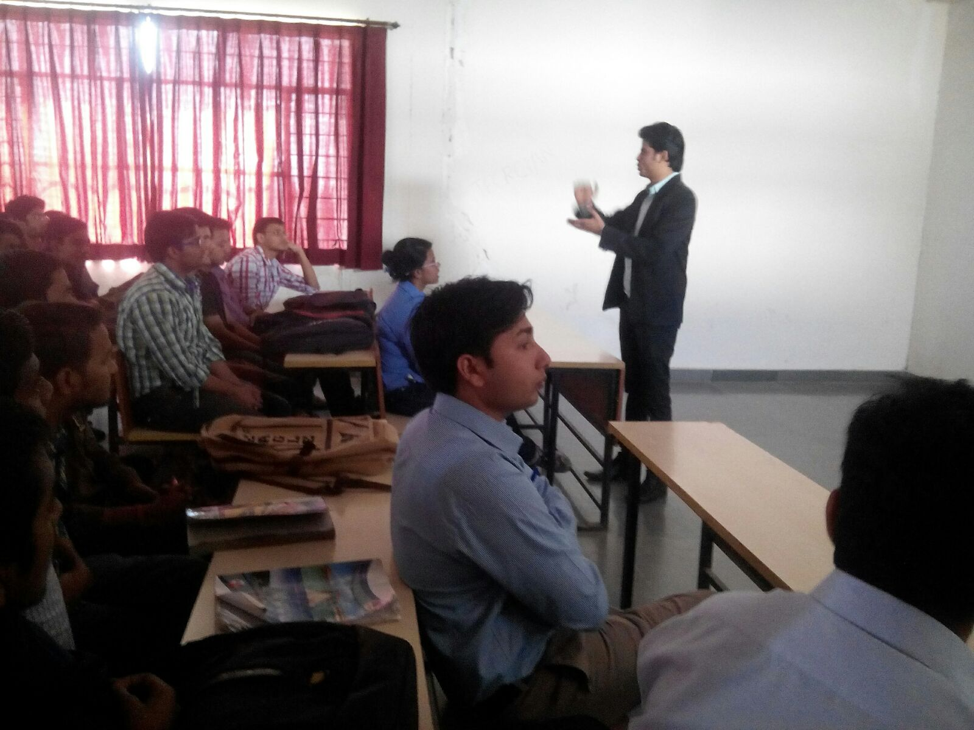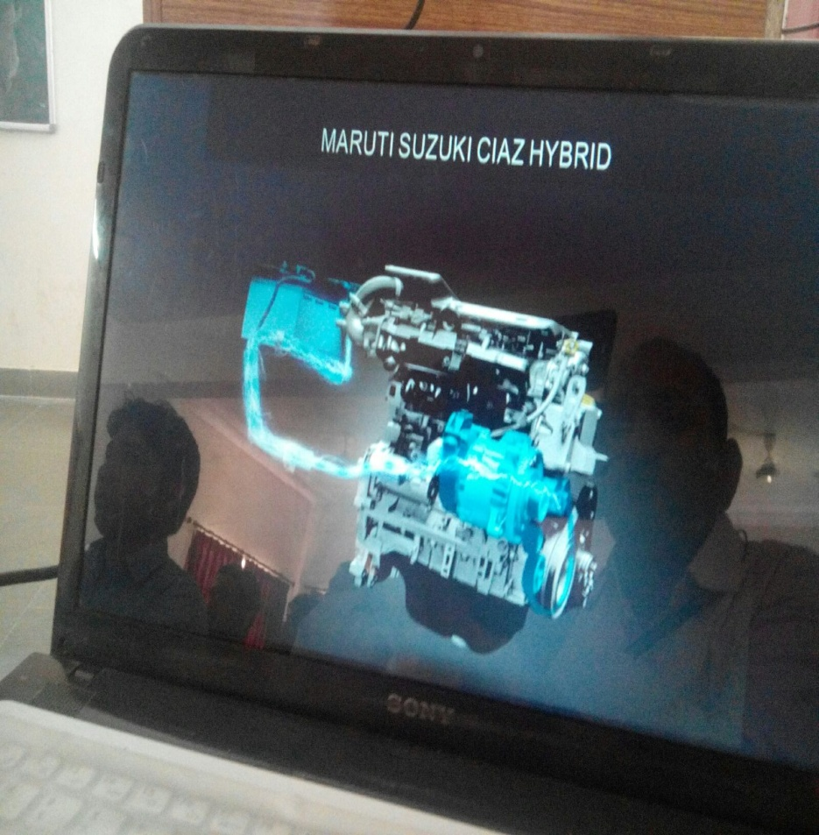

* Mr. Gaurav Jalan of Samyak IT Solutiuons Pvt.Limited delivered a talk on “ProE and CATIA” on 11 March 2016

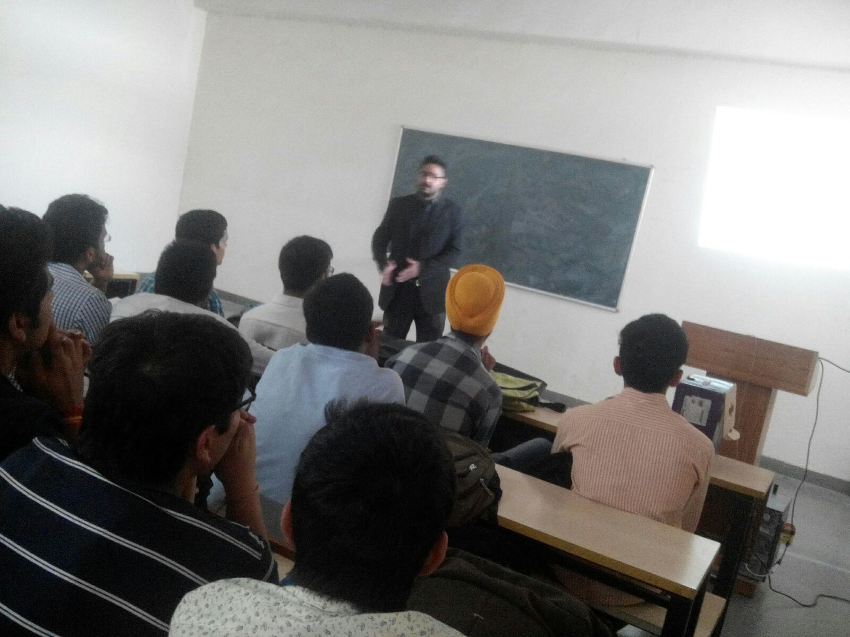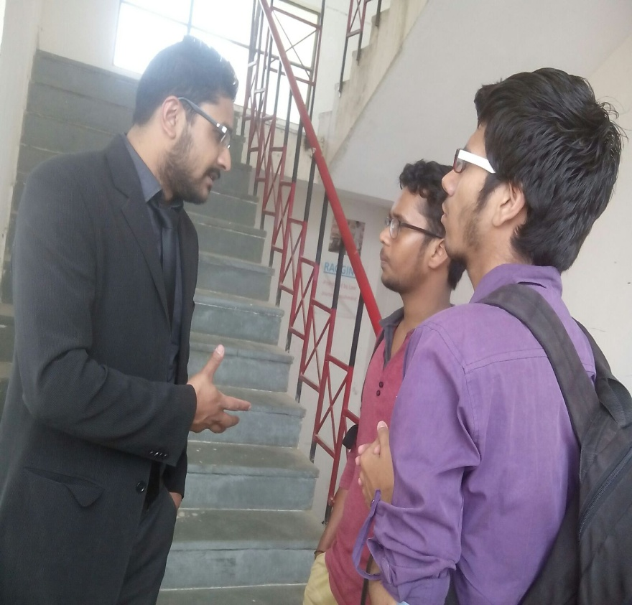

* Mr. Siddharth Singh, Business Head-TechieNest delivered a talk on “ Importance of Summer Internship in current Industrial Scenario” on 23 Jan,2016

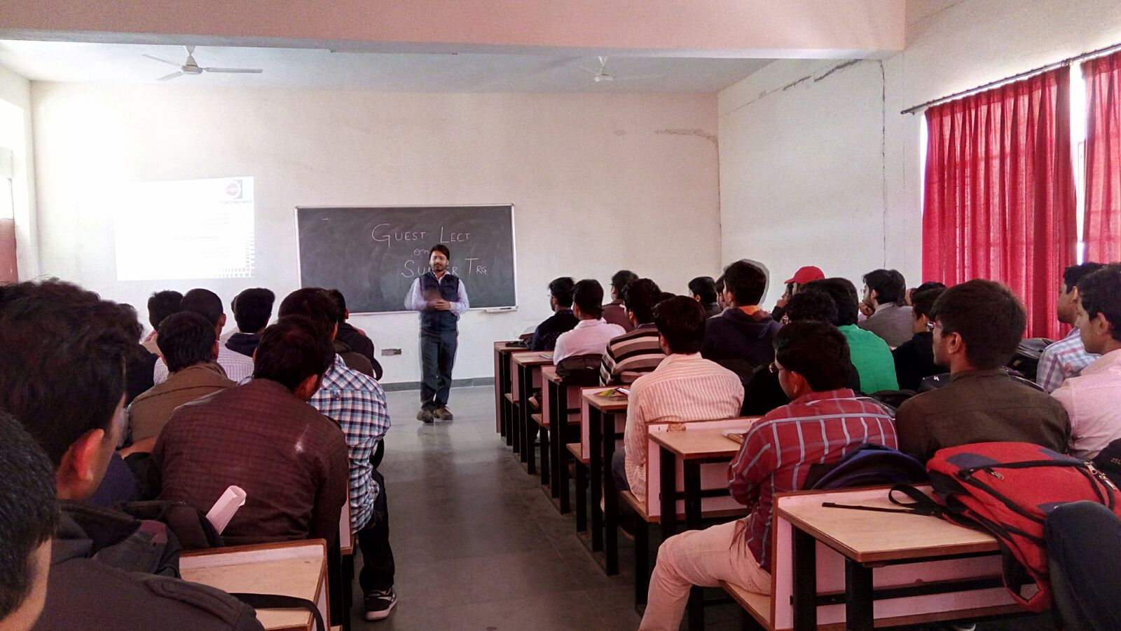

Engineer’s Day celebration(15/9/2015

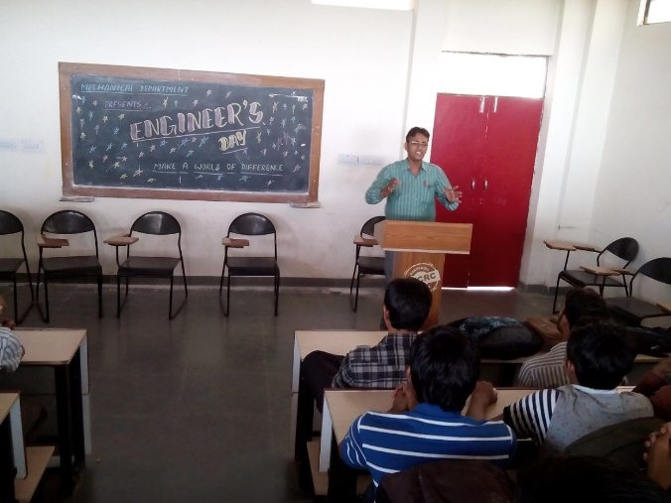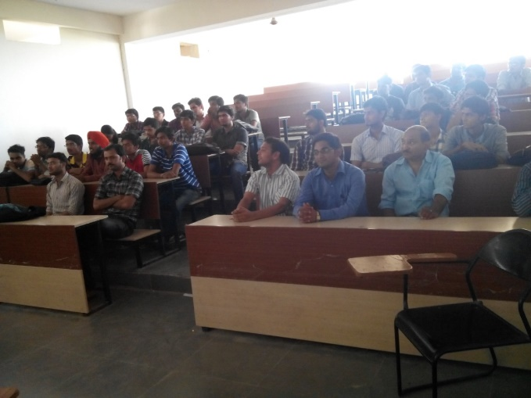

* Youth Day celebration (12/1/2016)

